Poetry Packet

Kelsey Arsenault

ABUSE

Acrostic Poem…………………………………………………….. Page 1
Wordle…………………………………………..…………………….Page 2
Free Verse…………………………………………………………….Page 3
Haiku…………………………………………………………………….Page 4
Lyric (Alyssa lies)…………………………………………………..Page 5
List poem………………………………………………………………Page 6
Just Because………………………………………………………….Page 7
I Don’t Understand………………………………………………..Page 8
I Am………………………………………………………………………Page 9
Creed…………………………………………………………………….Page 10

ABUSE…

Always coming home drunk
Beating down the door while I hide
Under my bed hoping you won’t find me
Seconds later you grab me and my life flashes before me
Everything you said was a lie you don’t love me

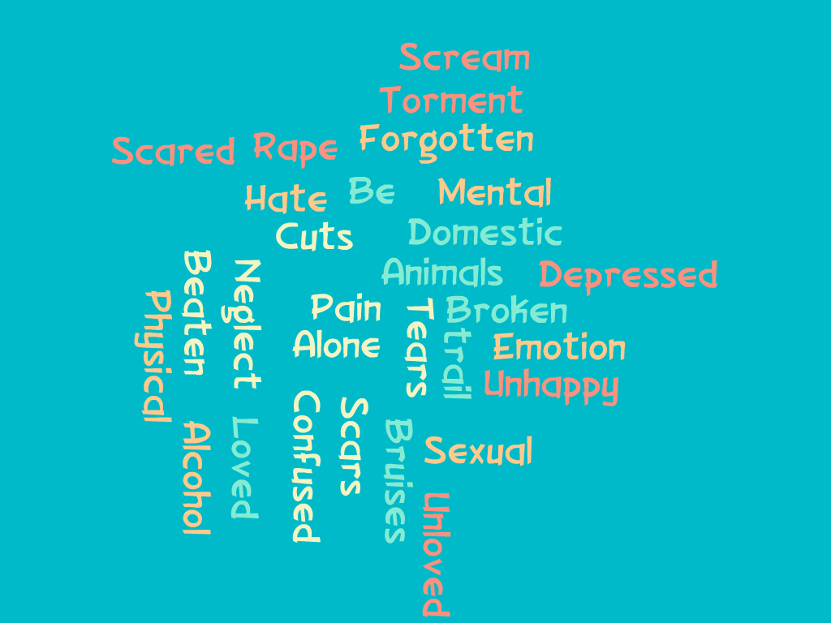

Why…

Why am I so plain
Why do I go through so much pain
Why can’t I ever be happy
Why do you abuse me and slap me
My body is covered in bruises and scraps
Will I ever escape
Why don’t you love me
Why?

Haiku…

They are people too
They should not go through abuse
Love all animals

Jason Michael Carroll - Alyssa Lies Lyrics

I came home with tear-filled eyes
And said to him, "Daddy, Alyssa lies"

"Alyssa lies to the classroom
Everyday
Lies to the teachers
Tries to cover the bruises"

"Please bless my mom and dad
And my new friend Alyssa
I know she needs you bad

List….

Kids that are tired of being hurt
They get beat
They get punished
They get tortured
No one stands up
But what do they mean to you
What do they bring to the world
Why do we do it
Makes us feel good about ourselves
But, Please
Don’t hit me
Abuse me
Yeah, I’ll go on in life
Full of hate

Just Because…

Just because I’m not human
Doesn’t mean you can’t love me
Doesn’t mean I have to be punished
Doesn’t mean I don’t have feelings
Just because you don’t want a kid
Doesn’t mean you have to neglect me
Doesn’t mean you have to beat me
Doesn’t mean I have to feel unwanted
Just because you don’t love me
You don’t have to hurt me
You don’t have to forget about me
You don’t have to keep me
Just because who you are
Makes me not want to live

I Don’t Understand…

I don’t understand…
Why I can’t be loved
What I even did wrong
Why you hate me
But most of all…
Why people don’t help save me
Why I can’t have a normal life
Why I can’t just hide from you
What I understand most is…
That I am alive
That this isn’t humane
That somewhere out there someone cares

I Am…

I am
Scared, Hurt, Sad
I like when I’m not around you when you’re having a bad day
I like seeing smiling faces and Laughter from others
Deep down I know you have to love me in there somewhere
I know when I grow up I’ll never treat my kids like you treated me
Fearful of what my life is going to be like
Shattered from this life
This is me
I believe in the strength of others to help me
The happiness around me in the world
The human rights that I share with others
The selflessness in others

Creed…
I believe in the rights of all
The pain behind a child’s cry
The sadness in an animal’s eyes
The lies used to cover up
The bruises shown upon the arms
Fear, Pain, Secrets
But any one deserves it
I believe in healing a child’s hurt
I believe in making a difference
I believe in everyone being loved
Healing, Scars, Change
And I believe in rights of all

